- 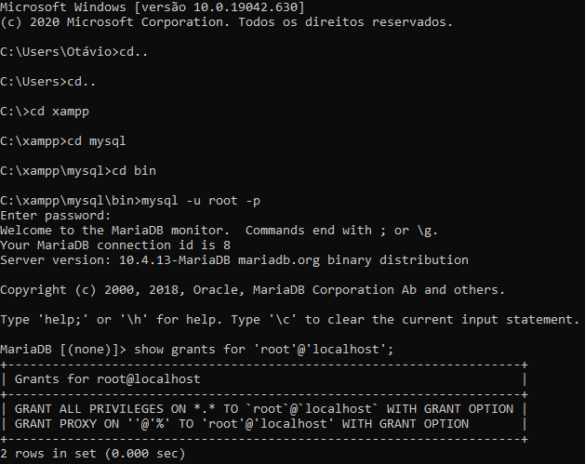
- 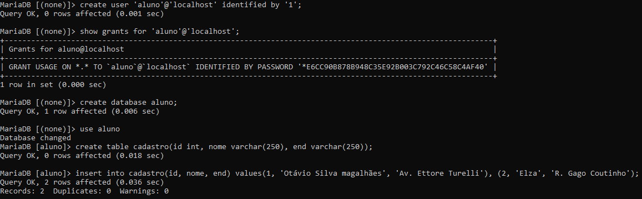
- 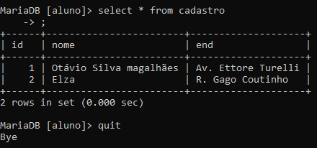
- 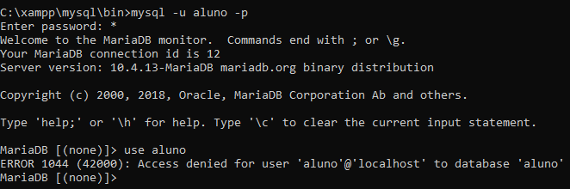
- 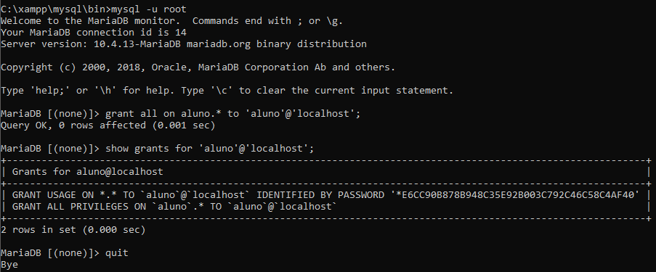
- 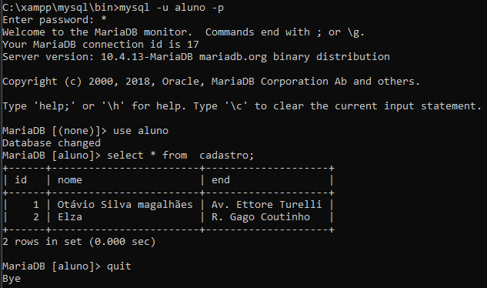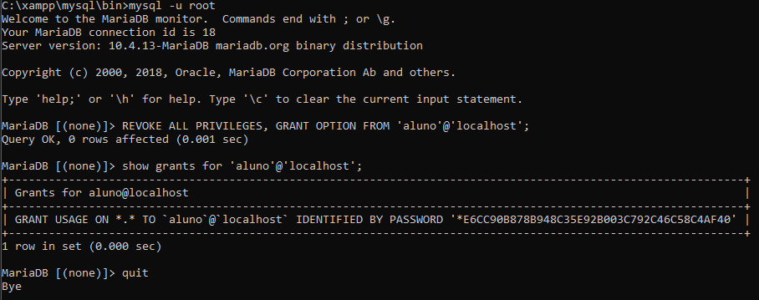
- 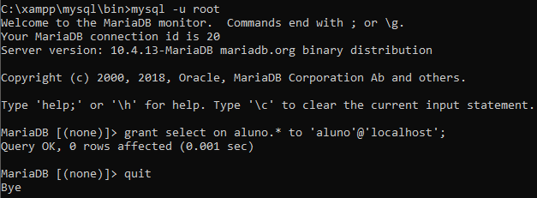
- 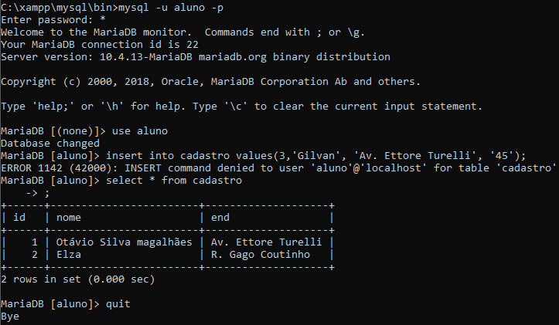
- 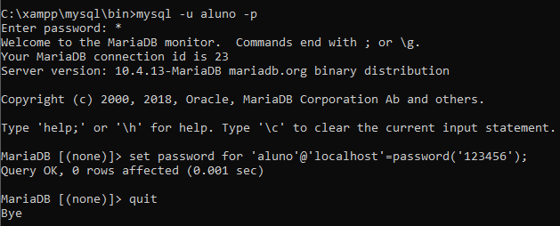

Microsoft Windows [versão 10.0.19042.630]
(c) 2020 Microsoft Corporation. Todos os direitos reservados.

C:\Users\Otávio>cd..

C:\Users>cd..

C:\>cd xampp

C:\xampp>cd mysql

C:\xampp\mysql>cd bin

C:\xampp\mysql\bin>mysql -u root -p
Enter password:
Welcome to the MariaDB monitor. Commands end with ; or \g.
Your MariaDB connection id is 8
Server version: 10.4.13-MariaDB mariadb.org binary distribution

Copyright (c) 2000, 2018, Oracle, MariaDB Corporation Ab and others.

Type 'help;' or '\h' for help. Type '\c' to clear the current input statement.

MariaDB [(none)]> show grants for 'root'@'localhost';
+---------------------------------------------------------------------+
| Grants for root@localhost |
+---------------------------------------------------------------------+
| GRANT ALL PRIVILEGES ON *.* TO `root`@`localhost` WITH GRANT OPTION |
| GRANT PROXY ON ''@'%' TO 'root'@'localhost' WITH GRANT OPTION |
+---------------------------------------------------------------------+
2 rows in set (0.000 sec)

MariaDB [(none)]> create user 'aluno'@'localhost' identified by '1';
Query OK, 0 rows affected (0.001 sec)

MariaDB [(none)]> show grants for 'aluno'@'localhost';
+--------------------------------------------------------------------------------------------------------------+
| Grants for aluno@localhost |
+--------------------------------------------------------------------------------------------------------------+
| GRANT USAGE ON *.* TO `aluno`@`localhost` IDENTIFIED BY PASSWORD '*E6CC90B878B948C35E92B003C792C46C58C4AF40' |
+--------------------------------------------------------------------------------------------------------------+
1 row in set (0.000 sec)

MariaDB [(none)]> create database aluno;
Query OK, 1 row affected (0.006 sec)

MariaDB [(none)]> use aluno
Database changed
MariaDB [aluno]> create table cadastro(id int, nome varchar(250), end varchar(250));
Query OK, 0 rows affected (0.018 sec)

MariaDB [aluno]> insert into cadastro(id, nome, end) values(1, 'Otávio Silva magalhães', 'Av. Ettore Turelli'), (2, 'Elza', 'R. Gago Coutinho');
Query OK, 2 rows affected (0.036 sec)
Records: 2 Duplicates: 0 Warnings: 0

MariaDB [aluno]> select * from cadastro
-> ;
+------+------------------------+--------------------+
| id | nome | end |
+------+------------------------+--------------------+
| 1 | Otávio Silva magalhães | Av. Ettore Turelli |
| 2 | Elza | R. Gago Coutinho |
+------+------------------------+--------------------+
2 rows in set (0.000 sec)

MariaDB [aluno]> quit
Bye

C:\xampp\mysql\bin>mysql -u root -p
Enter password:
Welcome to the MariaDB monitor. Commands end with ; or \g.
Your MariaDB connection id is 9
Server version: 10.4.13-MariaDB mariadb.org binary distribution

Copyright (c) 2000, 2018, Oracle, MariaDB Corporation Ab and others.

Type 'help;' or '\h' for help. Type '\c' to clear the current input statement.

MariaDB [(none)]> use aluno
Database changed
MariaDB [aluno]> quit
Bye

C:\xampp\mysql\bin>mysql -u root -p
Enter password: ****
ERROR 1045 (28000): Access denied for user 'root'@'localhost' (using password: YES)

C:\xampp\mysql\bin>mysql -u aluno -p
Enter password: ****
ERROR 1045 (28000): Access denied for user 'aluno'@'localhost' (using password: YES)

C:\xampp\mysql\bin>mysql -u aluno -p
Enter password: *
Welcome to the MariaDB monitor. Commands end with ; or \g.
Your MariaDB connection id is 12
Server version: 10.4.13-MariaDB mariadb.org binary distribution

Copyright (c) 2000, 2018, Oracle, MariaDB Corporation Ab and others.

Type 'help;' or '\h' for help. Type '\c' to clear the current input statement.

MariaDB [(none)]> use aluno
ERROR 1044 (42000): Access denied for user 'aluno'@'localhost' to database 'aluno'
MariaDB [(none)]> quit
Bye

C:\xampp\mysql\bin>mysql -u root
Welcome to the MariaDB monitor. Commands end with ; or \g.
Your MariaDB connection id is 13
Server version: 10.4.13-MariaDB mariadb.org binary distribution

Copyright (c) 2000, 2018, Oracle, MariaDB Corporation Ab and others.

Type 'help;' or '\h' for help. Type '\c' to clear the current input statement.

MariaDB [(none)]> grant all on aluno. to 'aluno'@'localhost';
ERROR 1064 (42000): You have an error in your SQL syntax; check the manual that corresponds to your MariaDB server version for the right syntax to use near 'to 'aluno'@'localhost'' at line 1
MariaDB [(none)]> quit
Bye

C:\xampp\mysql\bin>mysql -u root
Welcome to the MariaDB monitor. Commands end with ; or \g.
Your MariaDB connection id is 14
Server version: 10.4.13-MariaDB mariadb.org binary distribution

Copyright (c) 2000, 2018, Oracle, MariaDB Corporation Ab and others.

Type 'help;' or '\h' for help. Type '\c' to clear the current input statement.

MariaDB [(none)]> grant all on aluno.* to 'aluno'@'localhost';
Query OK, 0 rows affected (0.001 sec)

MariaDB [(none)]> show grants for 'aluno'@'localhost';
+--------------------------------------------------------------------------------------------------------------+
| Grants for aluno@localhost |
+--------------------------------------------------------------------------------------------------------------+
| GRANT USAGE ON *.* TO `aluno`@`localhost` IDENTIFIED BY PASSWORD '*E6CC90B878B948C35E92B003C792C46C58C4AF40' |
| GRANT ALL PRIVILEGES ON `aluno`.* TO `aluno`@`localhost` |
+--------------------------------------------------------------------------------------------------------------+
2 rows in set (0.000 sec)

MariaDB [(none)]> quit
Bye

C:\xampp\mysql\bin>mysql -u aluno -p
Enter password: *
Welcome to the MariaDB monitor. Commands end with ; or \g.
Your MariaDB connection id is 15
Server version: 10.4.13-MariaDB mariadb.org binary distribution

Copyright (c) 2000, 2018, Oracle, MariaDB Corporation Ab and others.

Type 'help;' or '\h' for help. Type '\c' to clear the current input statement.

MariaDB [(none)]> use aluno
Database changed
MariaDB [aluno]> select * from aluno;
ERROR 1146 (42S02): Table 'aluno.aluno' doesn't exist
MariaDB [aluno]> quit
Bye

C:\xampp\mysql\bin>mysql -u root -p
Enter password: ****
ERROR 1045 (28000): Access denied for user 'root'@'localhost' (using password: YES)

C:\xampp\mysql\bin>quit
'quit' não é reconhecido como um comando interno
ou externo, um programa operável ou um arquivo em lotes.

C:\xampp\mysql\bin>mysql -u aluno -p
Enter password: *
Welcome to the MariaDB monitor. Commands end with ; or \g.
Your MariaDB connection id is 17
Server version: 10.4.13-MariaDB mariadb.org binary distribution

Copyright (c) 2000, 2018, Oracle, MariaDB Corporation Ab and others.

Type 'help;' or '\h' for help. Type '\c' to clear the current input statement.

MariaDB [(none)]> use aluno
Database changed
MariaDB [aluno]> select * from cadastro;
+------+------------------------+--------------------+
| id | nome | end |
+------+------------------------+--------------------+
| 1 | Otávio Silva magalhães | Av. Ettore Turelli |
| 2 | Elza | R. Gago Coutinho |
+------+------------------------+--------------------+
2 rows in set (0.000 sec)

MariaDB [aluno]> quit
Bye

C:\xampp\mysql\bin>mysql -u root
Welcome to the MariaDB monitor. Commands end with ; or \g.
Your MariaDB connection id is 18
Server version: 10.4.13-MariaDB mariadb.org binary distribution

Copyright (c) 2000, 2018, Oracle, MariaDB Corporation Ab and others.

Type 'help;' or '\h' for help. Type '\c' to clear the current input statement.

MariaDB [(none)]> REVOKE ALL PRIVILEGES, GRANT OPTION FROM 'aluno'@'localhost';
Query OK, 0 rows affected (0.001 sec)

MariaDB [(none)]> show grants for 'aluno'@'localhost';
+--------------------------------------------------------------------------------------------------------------+
| Grants for aluno@localhost |
+--------------------------------------------------------------------------------------------------------------+
| GRANT USAGE ON *.* TO `aluno`@`localhost` IDENTIFIED BY PASSWORD '*E6CC90B878B948C35E92B003C792C46C58C4AF40' |
+--------------------------------------------------------------------------------------------------------------+
1 row in set (0.000 sec)

MariaDB [(none)]> quit
Bye

C:\xampp\mysql\bin>grant select on aluno.* to 'aluno'@'localhost'
'grant' não é reconhecido como um comando interno
ou externo, um programa operável ou um arquivo em lotes.

C:\xampp\mysql\bin>mysql -u root
Welcome to the MariaDB monitor. Commands end with ; or \g.
Your MariaDB connection id is 19
Server version: 10.4.13-MariaDB mariadb.org binary distribution

Copyright (c) 2000, 2018, Oracle, MariaDB Corporation Ab and others.

Type 'help;' or '\h' for help. Type '\c' to clear the current input statement.

MariaDB [(none)]> grant select on aluno.* to 'aluno'@'localhost'
-> ;
Query OK, 0 rows affected (0.001 sec)

MariaDB [(none)]> quit
Bye

C:\xampp\mysql\bin>mysql -u root
Welcome to the MariaDB monitor. Commands end with ; or \g.
Your MariaDB connection id is 20
Server version: 10.4.13-MariaDB mariadb.org binary distribution

Copyright (c) 2000, 2018, Oracle, MariaDB Corporation Ab and others.

Type 'help;' or '\h' for help. Type '\c' to clear the current input statement.

MariaDB [(none)]> grant select on aluno.* to 'aluno'@'localhost';
Query OK, 0 rows affected (0.001 sec)

MariaDB [(none)]> quit
Bye

C:\xampp\mysql\bin>mysql -u aluno -p
Enter password: *
Welcome to the MariaDB monitor. Commands end with ; or \g.
Your MariaDB connection id is 21
Server version: 10.4.13-MariaDB mariadb.org binary distribution

Copyright (c) 2000, 2018, Oracle, MariaDB Corporation Ab and others.

Type 'help;' or '\h' for help. Type '\c' to clear the current input statement.

MariaDB [(none)]> use aluno
Database changed
MariaDB [aluno]> select * from cadastro;
+------+------------------------+--------------------+
| id | nome | end |
+------+------------------------+--------------------+
| 1 | Otávio Silva magalhães | Av. Ettore Turelli |
| 2 | Elza | R. Gago Coutinho |
+------+------------------------+--------------------+
2 rows in set (0.000 sec)

MariaDB [aluno]> quit
Bye

C:\xampp\mysql\bin>mysql -u aluno -p
Enter password: *
Welcome to the MariaDB monitor. Commands end with ; or \g.
Your MariaDB connection id is 22
Server version: 10.4.13-MariaDB mariadb.org binary distribution

Copyright (c) 2000, 2018, Oracle, MariaDB Corporation Ab and others.

Type 'help;' or '\h' for help. Type '\c' to clear the current input statement.

MariaDB [(none)]> use aluno
Database changed
MariaDB [aluno]> insert into cadastro values(3,'Gilvan', 'Av. Ettore Turelli', '45');
ERROR 1142 (42000): INSERT command denied to user 'aluno'@'localhost' for table 'cadastro'
MariaDB [aluno]> select * from cadastro
-> ;
+------+------------------------+--------------------+
| id | nome | end |
+------+------------------------+--------------------+
| 1 | Otávio Silva magalhães | Av. Ettore Turelli |
| 2 | Elza | R. Gago Coutinho |
+------+------------------------+--------------------+
2 rows in set (0.000 sec)

MariaDB [aluno]> quit
Bye

C:\xampp\mysql\bin>mysql -u aluno -p
Enter password: *
Welcome to the MariaDB monitor. Commands end with ; or \g.
Your MariaDB connection id is 23
Server version: 10.4.13-MariaDB mariadb.org binary distribution

Copyright (c) 2000, 2018, Oracle, MariaDB Corporation Ab and others.

Type 'help;' or '\h' for help. Type '\c' to clear the current input statement.

MariaDB [(none)]> set password for 'aluno'@'localhost'=password('123456');
Query OK, 0 rows affected (0.001 sec)
MariaDB [(none)]> quit
Bye

